A guide to planning your VET workforce's digital skill development

Planning your VET workforce's digital skills is important.
The Vocational Education and Training (VET) sector plays an important role in Australia’s economic, social and cultural development as it provides the skills Australians need now and into the future (Australian Government. No date).

It is predicted that “375 million jobs will be automated by 2030” (Gekara, et al 2020, pg vii), so it is important for Registered Training Organisations (RTOs) to prepare their trainers now so they have the digital skills needed to train people with the skills needed to support employers’ needs, both now and in the future.

People who can also work alongside robots, both now and in the future, will be the ones who will survive in this digitally disrupted world (Wilson & Daugherty, 2018).

Existing examples of digital disruption

Digital disruption | Industry | Examples
Artificial Intelligence/ Automation | Aged care | Digital assistants help remind people about taking their medicine  https://www.mirusaustralia.com/aged-care-blog/aged-care-management/how-can-artificial-intelligence-help-australian-aged-care-facilities/  https://www.mirusaustralia.com/aged-care-blog/aged-care-management/how-can-artificial-intelligence-help-australian-aged-care-facilities/
Artificial Intelligence/ Automation | Building and construction | Smart houses/buildings are more energy efficient https://www.architectureanddesign.com.au/news/smart-buildings-overcoming-australia-s-energy-cris
Artificial Intelligence/ Automation | Urban planning | Smart cities where people can easily find a car park https://www.smartparking.com/solutions/smart-cities
Artificial Intelligence/ Automation | Logistics | Driverless trucks/cars which can be safer and more productive than trucks/cars with human drivers  http://www.forconstructionpros.com/construction-technology/article/12191275/6-areas-where-technology-is-revolutionizing-the-construction-industry
Artificial Intelligence/ Automation | Mining / Agriculture / Aquaculture | Drones for monitoring remote areas for agriculture/ aquaculture or for detecting possible new mine sites in remote areas  http://www.fao.org/3/i8494en/i8494en.pdf  https://wingtra.com/drone-mapping-applications/mining-and-aggregates/
Artificial Intelligence/ Automation | Construction & Mining industry | Personal protective equipment (PPE) with sensors and cameras that will provide information about a person’s surrounding environment and how to move through it more safely http://www.forconstructionpros.com/construction-technology/article/12191275/6-areas-where-technology-is-revolutionizing-the-construction-industry
Data analytics / visualization | All Industries | Data has grown exponentially, offering insights into how businesses / people are functioning, and offering predictions for the future  https://www.datapine.com/blog/best-data-visualizations/
Modern offices | All Industries | Multifunctional office spaces where people are assigned a locker to store their possessions, and use different spaces as required  https://www.buildings.com/articles/28075/maximize-office-workspace-making-it-multifunctional-and-flexible
Supporting VET trainers as dual professionals
When planning your VET workforce's digital skills, you also need to remember that VET trainers are dual professionals, so they also need to have the digital skills to support “new and innovative teaching methods” (Reeson, et al, 2016 pg 5) which will enable “new ways of thinking” (PwC, No date, pg 4).
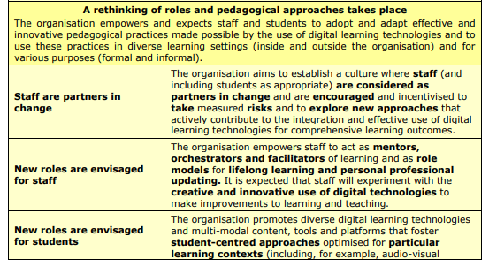
This will require the right leadership around “rethinking roles and pedagogical approaches” (Digitally Competent Educational Organisations (DigCompOrg), Kampylis, et al, 2015, pg 23-24).

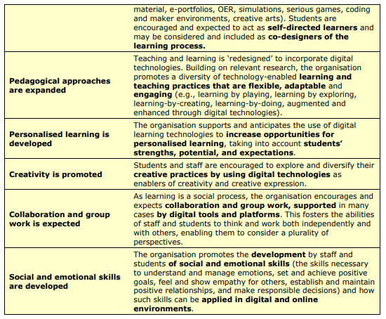

Digital Competence Framework for Educators (DigCompEdu) (Redecker, 2017, pg 19, 21-22) provides guidance in the areas of:
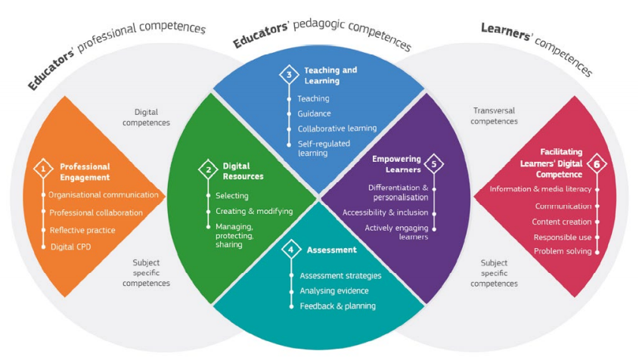
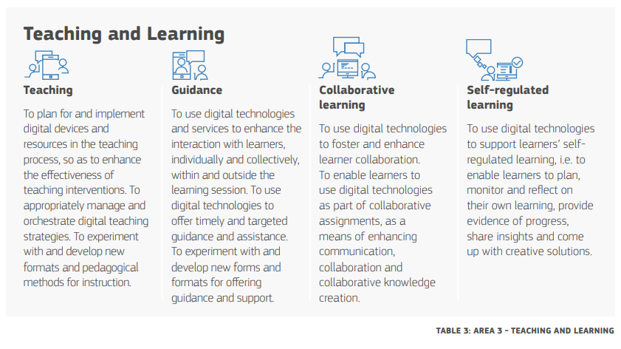
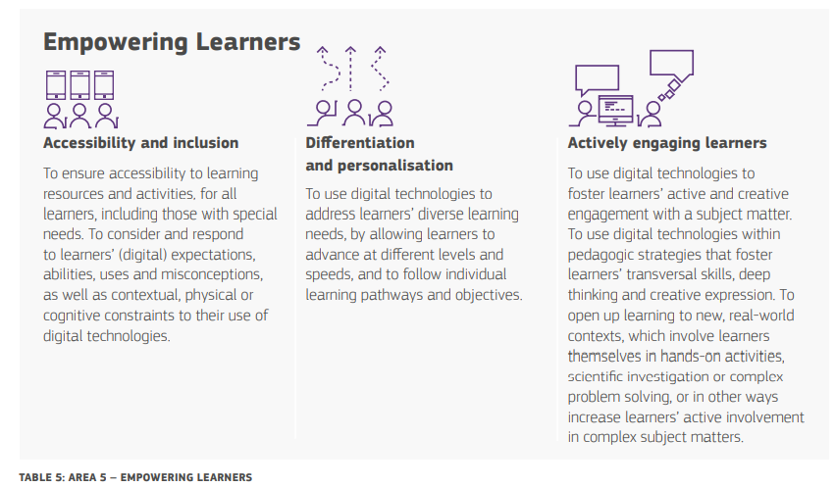

This requires a key focus on active learning (Dale, 1969):
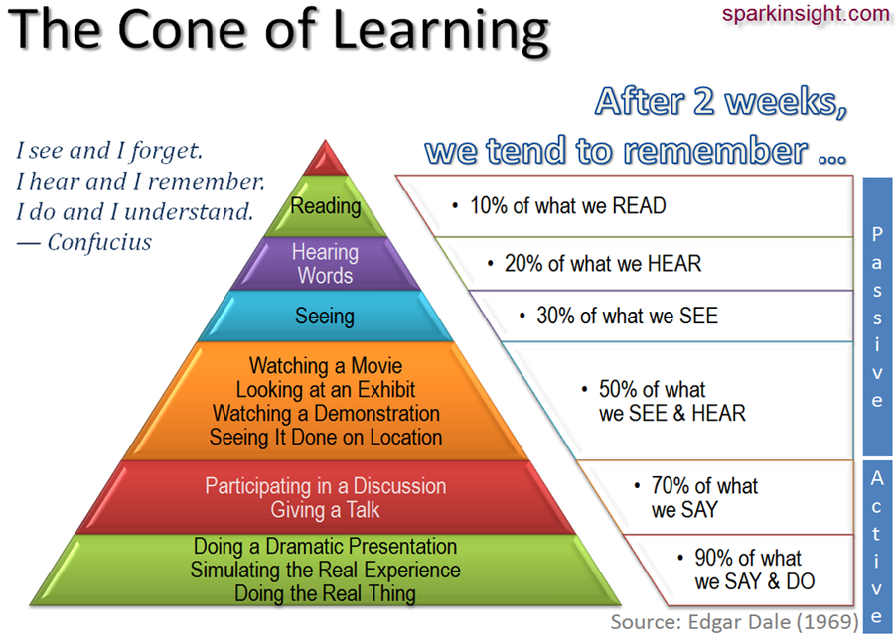
Image from: https://teachernoella.weebly.com/dales-cone-of-experience.html
The types of learning spaces needed for training will also need to be taken into consideration to better reflect the workplace of the future.
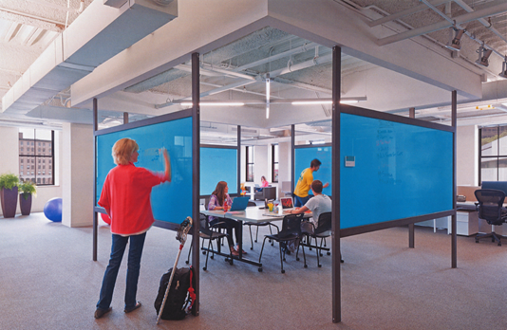
CC-BY Image from Wikimedia Commons – https://commons.wikimedia.org/wiki/File:Modern_Architectural_Details-_brightcove_Glass_Dry_Marker_Panel_System_by_Phil_Manker_(7349701020).jpg
Using the Australian Workforce Digital Skills Framework (AWDSF):
Australian Workforce Digital Skills Framework (AWDSF) provides a framework which illustrates the broad digital skills needed to work effectively, both now and into the future (Gekara, et al, 2019).
AWDSF consists of digital skills category dimensions (Gekara, et al. 2019, pg 32):
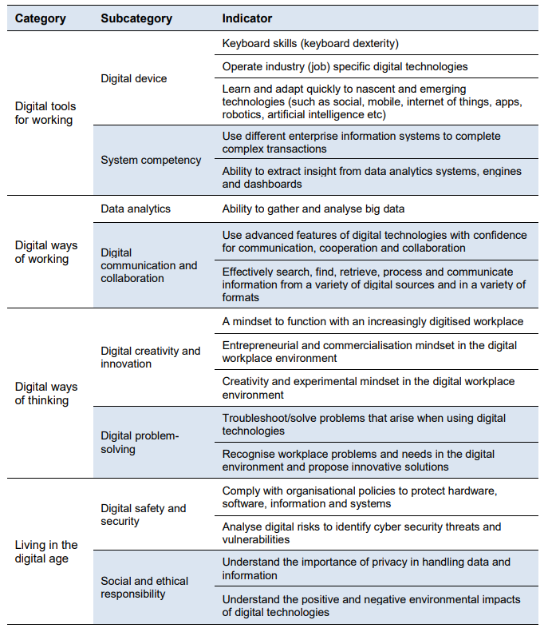

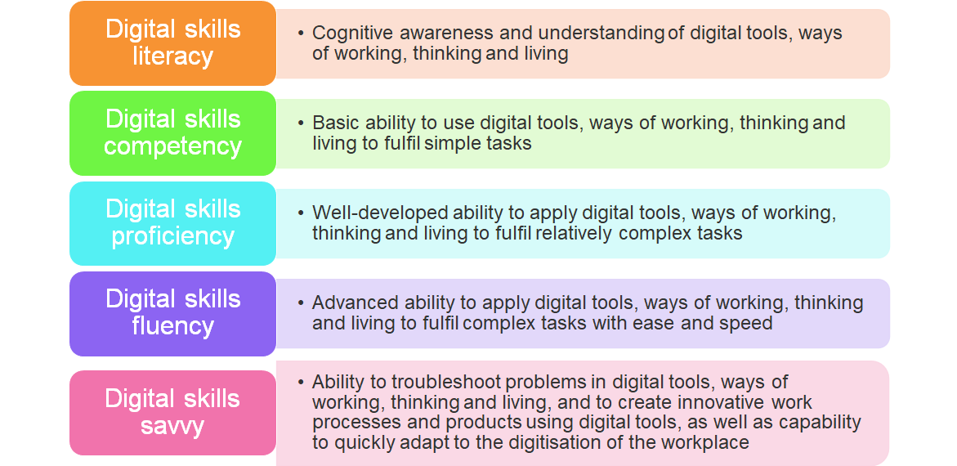
AWDSF Five levels of need/performance (Gekara, et al. 2019, pg 33-34)

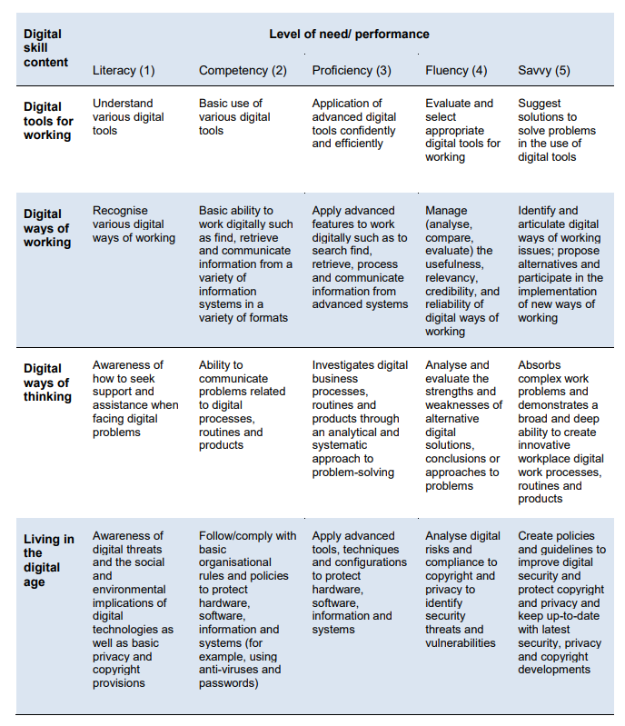

Preparing your VET workforce for the future of work
Using an Appreciative Inquiry (Cooperrider & Srivastva, 1987) approach can help you prepare your VET workforce for the future of work by:
- Defining the topic of enquiry, e.g., Preparing your VET workforce for the future of work
- Discovering what is the status quo of your current VET workforce’s digital skills
- Dreaming what your VET workforce’s digital skills should look like, both now and into the future
- Designing ways to achieve what your VET workforce’s digital skills should look like
- Destiny - implementing what you have designed to prepare your VET workforce for the future of work

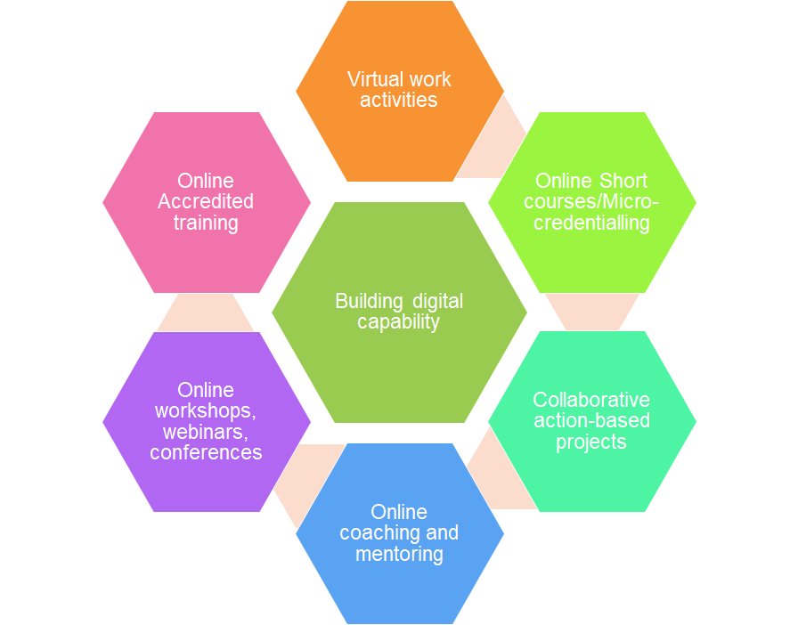
Building digital capability using digital approaches
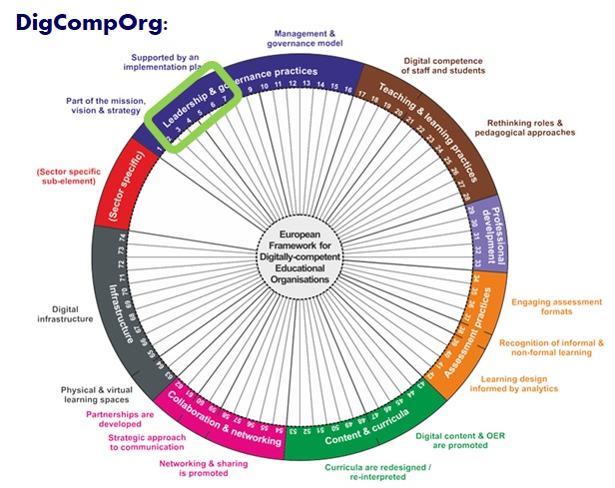
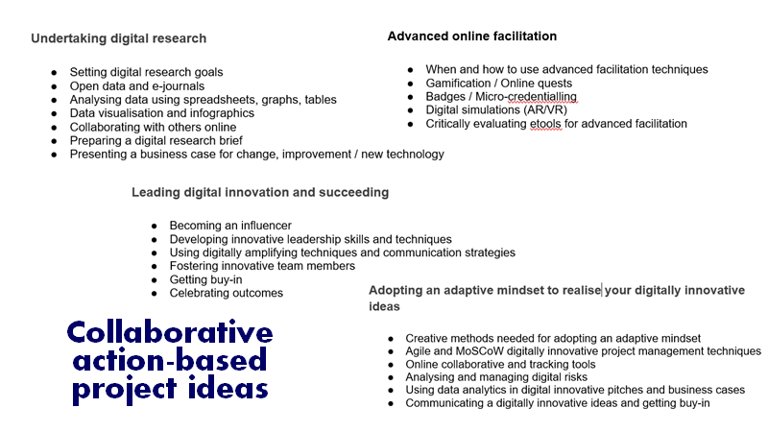
References
Australian Government. No date. About the skills sectors, Department of Education, Skills & Employment https://www.employment.gov.au/about-skills-sector
Cooperrider, D. L. & Srivastva, S. 1987. Appreciative inquiry in organizational life. In Woodman, R. W. & Pasmore, W.A. (eds.). Research in Organizational Change and Development. Vol. 1. Stamford, CT: JAI Press. pp. 129–169.
Dale, E. (1969). Audiovisual methods in teaching (3rd ed.). New York: Dryden Press.
Gekara, V. Snell, D. Molla, A. Karanasios, S. & Thomas, A. 2019. Skilling the Australian workforce for the digital economy, NCVER, https://www.ncver.edu.au/research-and-statistics/publications/all-publications/skilling-the-australian-workforce-for-the-digital-economy
Gekara, V. Snell, D. Molla, A. & Karanasios, S. 2020. A scan of approaches taken by Australia to build the digital skills of the existing workforce in response to digital transformation of industry, Australian Industry Standards, https://digitalskillsformation.org.au/wp-content/uploads/2020/09/FINAL-Australian-Scan-Report_Approved.pdf
Kampylis, P., Punie, Y. & Devine, J. 2015. Promoting Effective Digital-Age Learning - A European Framework for Digitally-Competent Educational Organisations; https://publications.jrc.ec.europa.eu/repository/bitstream/JRC98209/jrc98209_r_digcomporg_final.pdf
PwC. No date. Workforce of the future: The competing forces shaping 2030, https://www.pwc.com/gx/en/services/people-organisation/publications/workforce-of-the-future.html
Redecker, C. 2017. European Framework for the Digital Competence of Educators: DigCompEdu. Punie, Y. (ed). Ehttps://ec.europa.eu/jrc/en/publication/eur-scientific-and-technical-research-reports/european-framework-digital-competence-educators-digcompedu
Reeson, A. Mason, C. Sanderson, T. Bratanova, A. & Hajkowicz, S. 2016. The VET Era: Equipping Australia’s workforce for the future digital economy – Report for TAFE Queensland, CSIRO
Wilson, HJ. & Daugherty, PR. 2018. Collaborative Intelligence: Humans and AI Are Joining Forces, Technology, Harvard Business Review, https://hbr.org/2018/07/collaborative-intelligence-humans-and-ai-are-joining-forces

