Subject: Don’t forget to activate your Velg Training sibling account

Dear Insert Name

As part of our commitment to your continuous professional development, we have previously generated an invitation for you to join our paid corporate / plus membership with Velg Training.

We really want to make your life easier by giving you access to this membership so please click on the link on the email recently sent to you so you can log in and start enjoying great benefits such as:

- Great PD free PD by way of their Members Lunch Box series of webinars, a suite of Velg Casts and also their Standards at a Glance resource;
- A weekly curated newsletter to keep up to date with all that’s going on in the VET sector; and
- An extensive library of resources to help you in your role
You can view a short recording here to help you get the most out of our Velg Training membership.
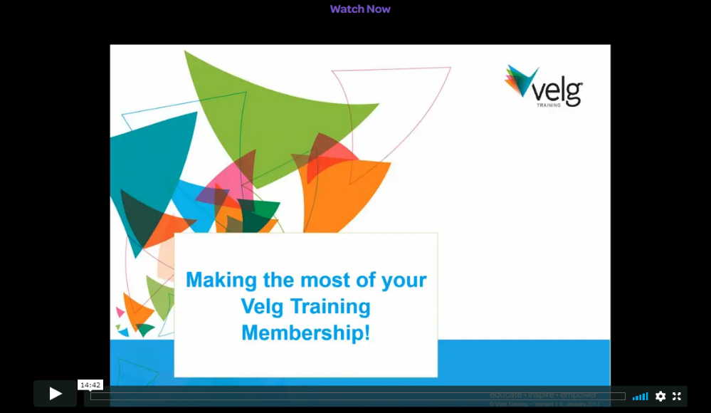

If you experience any difficulty with the activation of your account please contact the Velg Training membership team for further assistance on 07 3866 0888 and selecting option ‘4’ for membership.

