Subject: Our commitment to helping you succeed in your role / Help us help you!

Dear Insert Name

As part of our commitment to your continuous professional development, insert your organisation’s name have purchased a corporate / plus membership with Velg Training.

This membership entitles our team to:
- Great PD free PD by way of their Members Lunch Box series of webinars, a suite of Velg Casts and also their Standards at a Glance resource;
- A weekly curated newsletter to keep up to date with all that’s going on in the VET sector; and
- An extensive library of resources to help you in your role
You can view a short recording here to help you get the most out of our Velg Training membership.
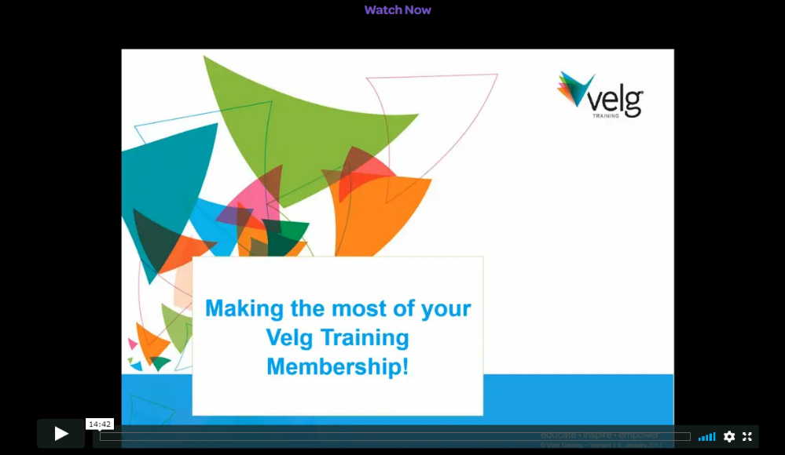

Very soon you will receive/you have been sent an email containing your username and a link to activate your account, please ensure you action this so you can start utilising this great resource we have purchased to help make your life easier.

If you have previously had an account with Velg Training please get in touch with their membership team as they may be able to merge or update your account details so your PD history with them is all in the one spot.

If you have any questions about this subscription, I am our internal contact, but you can also contact their membership team via members@velgtraining.com for further assistance.

